**BSI UI Analysis- Backup - Restore**

**Custom Backup / Restore**

**Type: Read only Grid**

**Columns:**

* **Description**
* **Value**

**Features:**

**Buttons:**

**Backup**

**Restore**

**Exit**

**Restore:**

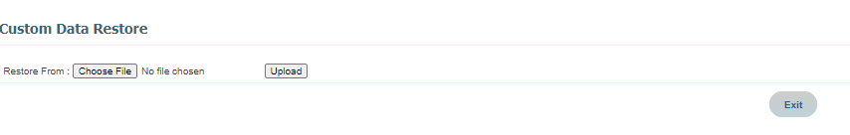

**Solution:**

**Move all system related tools to a gear icon drop down**

**Improve the UI with the new reusableGrid and dynamicForm**

**Improve the layout , buttons**

**Links to any related screens and add should be buttons in the new ui**

**Use the New improved icons**

**Current Documentation:**

**Custom Backup/Restore**

The Custom Backup/Restore tool is used to:

* Backup current TaxFactory™ custom data for selected data sets
* Restore the TaxFactory custom data that was backed-up

**To backup custom data:**

Use the Backup tool to manually back-up custom data to another source or another computer on your network in an XML file format. The backup process includes all custom elements in the selected data set in your TaxFactory database. The backed-up custom data can be then be used to restore data when creating a new data set. Use the Jump To menu to select System Tools.

**Tip:**  Assign separate backup file names to each data set to avoid overwriting a previous backup of a different data set.

1. On the **Custom Backup/Restore** page, click **Backup**, the **Custom Data Backup** page opens.
2. Select the data set you want to back-up.

**Note:** TaxFactory SaaS users can only backup one data set at a time in the XML file format. On-Premise users may backup all data sets into a single package file (*.pkg).

1. Click **Process**.
2. After processing is complete, the following options become available for selection:

**To save the backup file:**

Right-click the filename (.xml) and select **Save Target As....** to save the backup file.

**To view the audit report:**

Click the filename (.xml.out or .pkg.out) to view the audit report using PDF from the display screen.

**To restore custom data:**

**Note:** When entering a new name for the restored data set, do not use leading spaces.

1. On the **Custom Backup/Restore** page, click **Restore**, the **Custom Data Restore** page opens.
2. In the **Restore From** box, type the path and filename, or browse for the file.
3. In the **Restore To** section,
   * To restore the data set in the backup file to an existing data set name, select **Existing Data Set**, and select the desired **Data Set ID**.

**Note:** Restore is restricted in TaxFactory SaaS to only allow the selection of existing data sets. Rights also cannot be restored.

* + (Optional) To remove all custom data from the target data set, select Delete Existing Data (if any) in the Target Data Set.
  + To restore the data set in the backup file to a new data set name, select **A New Data Set**, and entered the desired **Data Set ID.**
  + (Optional) To restore all Rights from the custom data file into the target data set, select Restore Permission (Rights) records into the target Data Set.  This will only work if the login id used to backup the file is available in the database where the custom data is being restored.

1. Click **Process**.
2. After processing is complete, click the filename (.xml.out) to view the audit report using PDF from the display screen.

**To delete existing data (if any) in the target data set:**

1. Select the check box.
2. Click **Process**

**Custom Backup/Restore Status**

The Custom Backup/Restore Status screen keeps track and maintains the most recent status of a custom data backup or restore for a period of seven days. The most recent Custom Data Backup/Restore output file is retained in the application server temporary directory and is available for review from any client connected to application server for the same period of time.